**Homework 3**

* *First write a rough program before coding*
* *Attach the screenshot of your running code, mention any doubt or error you found while doing in the homework sheet.*
* *You will have to explain the logic in next class, take your time and submit it before 15th April 2021, 10:00PM*

**Q1) Python Program to Calculate the Area of a Triangle, square, and rectangle by taking user input**

Area of a triangle

b= float(input(‘Enter base measurements:’))

h= float(input(‘Enter height measurements:’))

areaoftri = 0.5*b*h

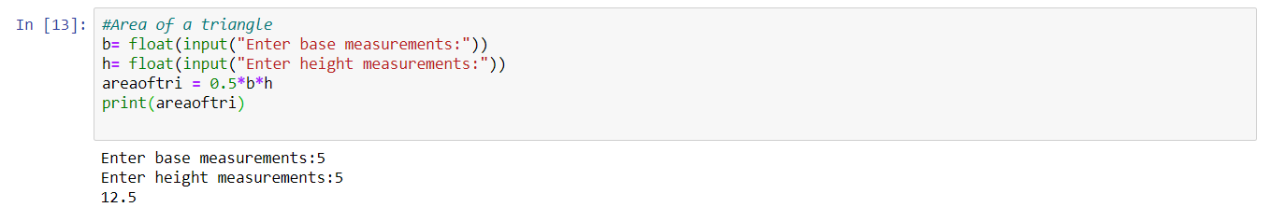

Area of Square

s= int(input(‘Enter Side Measurement:’))

areaofsqr = s*s

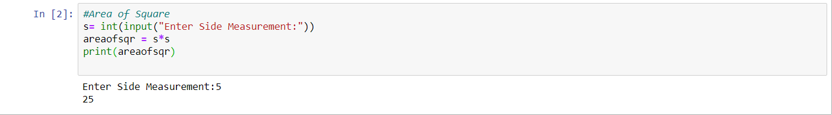

Area of Rectangle

l=int(input(‘Enter Length:’))

b=int(input(‘Enter Breadth:’))

areaofrec = l*b

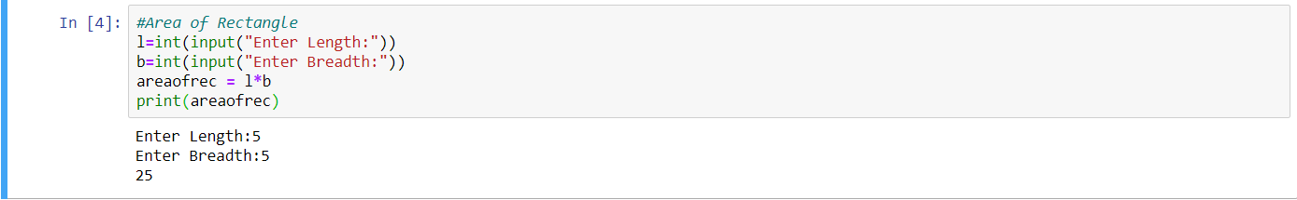

**Q2) Python Program to Convert Kilometers to Meters**

km = int((”Enter Km value:”))

m = km*1000

print(”The converted value in meters is:”,m)

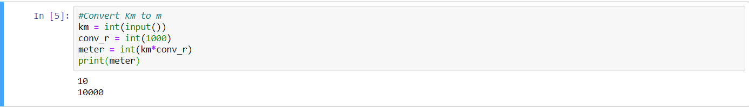

**Q3) Python Program to Convert Celsius To Fahrenheit**

deg_C= float(input(“Enter Celsius value:”))

conv_r= 9/5+32

deg_F = deg_C*conv_r

print(deg_F)

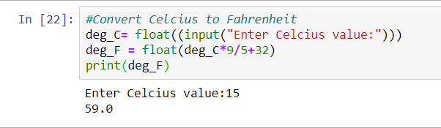

**Q4) Python Program for simple interest**

Simple Interest

p= float(input("Enter principal amount:"))

r= float(input("Enter Annual Interest Rate:"))

n= float(input("Enter No. of Years:"))

i= p*n*r

print("The Simple Interest is:",i)

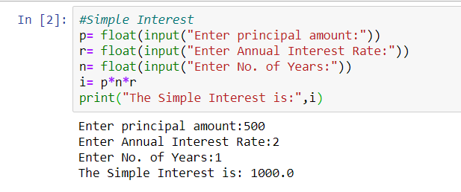

**Q5) Python Program for compound interest**

Compound Interest (in python ^ is **)

p= float(input("Enter principal amount:"))

r= float(input("Enter Interest rate:"))

n= float(input("Enter no. of times the interest is compounded:"))

t= float(input("Enter the time period:"))

nr= float(1+(r/n))

nt= float(n*t)

a= float(p*(nr**(nt)))

print("The Compounded Amount is:",a)

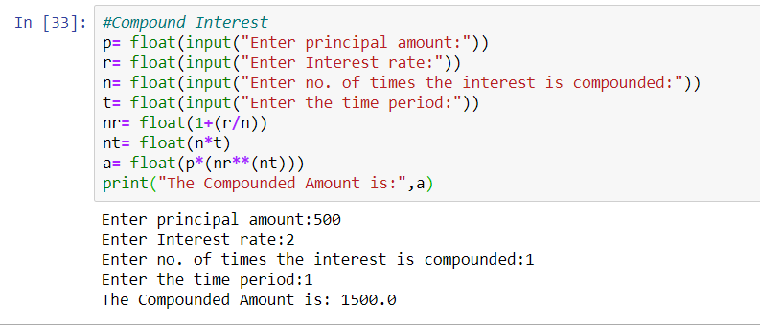

**Q6) Python Program for Program to find area of a circle**

r= input(‘Enter Radius value:’)

areaofcirc= pi*r*r

